**Assignment 5 – jQuery Selectors & Effects Demo**

**Student:** Uzbekbayev Bekarys  
**Group:** SE-2438  
**Project:** *AutoVerdict – Car Reviews and Comparisons*

**Objective**

The main goal of this assignment was to apply **jQuery selectors and effects** inside the existing AutoVerdict project.  
This practice helped to understand how to dynamically control webpage elements using jQuery functions such as .hide(), .show(), .fadeToggle(), and .css() for styling.

**Description**

Two interactive parts were implemented in the project:

1. **jQuery Selectors & Effects Demo**
   * Added to the main page (**index.html**).
   * Demonstrates how jQuery can select elements and apply effects.
   * Includes five buttons: **Hide**, **Show**, **Fade Toggle**, **Change Color**, and **Reset**.
   * Each button changes the visibility or color of the text using different jQuery methods.
   * It clearly shows how selectors and CSS manipulation work together.
2. **Tesla Fade Animation**
   * Added to the **reviews.html** page in the *Tesla Model 3 (2024)* review.
   * The main image now changes smoothly using **fade effects**.
   * Clicking **Next Image** triggers a smooth .fadeOut() → .fadeIn() transition between multiple Tesla pictures.
   * Demonstrates jQuery event handling and animation chaining.

**Result**

Both demos successfully display an understanding of jQuery fundamentals:

* Selecting elements using IDs and classes.
* Handling user events (clicks).
* Using animation methods for smoother visual transitions.
* Dynamically modifying CSS properties.

These features make the AutoVerdict project more interactive and visually appealing.

**Screenshots**

**Figure 1.** jQuery Selectors & Effects Demo on the main page  
**

**Figure 2.** Tesla Model 3 Gallery with Fade Animation  
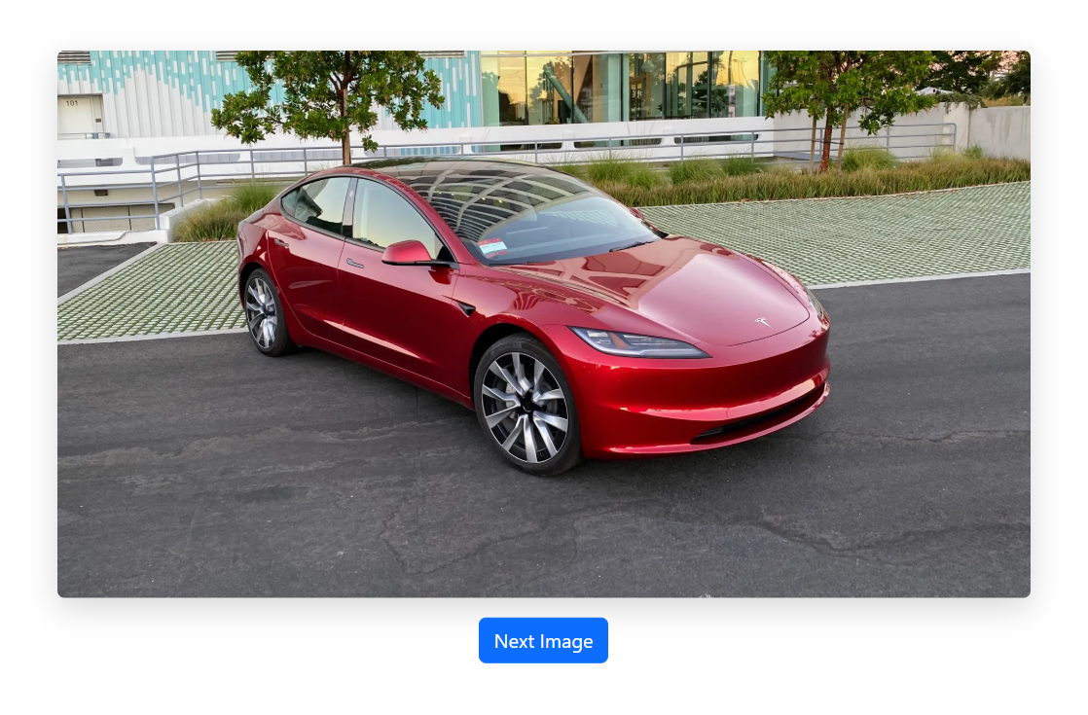

**Conclusion**

The assignment demonstrates practical skills in using jQuery for DOM manipulation, CSS control, and animations.  
Through these implementations, I learned how jQuery simplifies JavaScript code and makes user interaction smoother and more dynamic.